**S.R.DAV PUBLIC SCHOOL SONIA VIHAR SRE ONIA VIHAR SRE S**

**HLIDAY’S HOME WORK 2025-26**

**CLASS 1**

**ENGLISH:**

* **Revise all the work done in book and note book.**
* **Do one page of English Reading, writing and dictation(10words) daily.**
* **Write the given assignment  on A3 sheet using bold letters according to your Roll numbers.**
* **Roll no.1 to 4 Pictures of ’ee’ and “ll” sound words.**
* **Roll no.5to 7     Pictures of “oo” and ‘sh’ sound words**
* **Roll no. 8 t0 11  Pictures of ‘ch’ and ‘th’ sound words.**
* **Roll no.12 to 14    Pictures of ’ss’ and “ck” sound words.**
* **Roll no.15 to 17      Pictures of “ng” and ‘th’ sound words**
* **Roll no. 18 to 21 Pictures  showing one and many ,use of has/have,this/that.**
* **Read  comics and short stories books.**

**हिन्दी**

* **भाषा माधुरी पाठ 1 से 5**
* **भाषा अभ्यास: पेज 1से 20 दोहराए।**
* **अनुक्रमांक के अनुसार (A3 size sheet) पर सुंदर मात्राओ वाले चित्र बनाए।**
* **रोल नम्बर 1,2,3और 4आ, इ , ई की मात्रा वाले शब्दों के चित्र।**
* **रोल नम्बर 5,6,7और 8**

**उ,ऊ की मात्रा वाले शब्दों के चित्र।**

* **रोल नम्बर 9और10  ऋ  की मात्रा वाले शब्दों के चित्र।**
* **रोल नम्बर 11,13और 13 ए , ऐ की मात्रा वाले शब्दों के चित्र।**
* **रोल नम्बर 14,15और 16ओ, औ की मात्रा वाले शब्दों के चित्र।**
* **रोल नम्बर 17,18,19,20और 21 औ,अं  व अ: की मात्रा वाले शब्दों के चित्र।**
* **प्रतिदिन श्रुतलेख ( 20शब्द) व सुलेख लिखें।**
* **कहानियों की किताबे पढ़े।**

**Mathematics:**

* **Primary Mathematics    Revise page no.1 to 35**
* **Reverse counting 100 to 1**
* **Number name 1to 50**
* **Tables 2 to 5**
* **Draw objects using cutting of different shapes on A3 sheet.**
* **Make a chart on pre number concept showing(Big/small,Thick/thin Heavy/light)**

**E.V.S**

* **E.V.S Learn all the work done in notebook and book.**
* **Make a hygiene kit with the things you use for your cleanliness like Soap ,Shampoo,Dettol,Sanitizer,Toothpaste etc.**
* **Make a list of food items which you get from plants,  animals and junk food on  A4 sheet.**

**Computer:**

**Draw and Label Computer Parts*: Create a chart paper with different parts of a computer labeled, such as the monitor, keyboard, and mouse.**

**Computer Basics*: Learn about basic computer terms and concepts, such as what a computer is and how it's used.**

**नैतिक शिक्षा**

1. **पाठ 1,2 का समस्त कार्य दोहराए।**
2. **प्रार्थना लिखिए और याद करिए।**
3. **आर्य समाज के नियम 1, 3,4 तक याद करिए।**
4. **आर्य समाज का केसरिया रंग का ध्वज चित्र बनाए।**

**Art. Draw and colour --Primary colour ( Red, Yellow, Blue)Fruits, Umbrella, stationary objects, Sun flower. Make a Pen stand used waste material.  Step by Step - Page 1 to 10**

**G .K.  *Scrap book work\***

**• Make a collage which contains all the information related to India like National Flower, National Emblem, National Currency, National Fruit, National Game, National Animal, National Bird.**

**• Collect five types of  dry leaves of different flowers and stick them in your scrapbook and also write their names on them.**

**• Write the names of five such fruits and paste their pictures which are eaten in summer and juice is also made from them.**

**• Paste pictures of our freedom fighters and also write their names.**

**• Collect any five current affairs from the newspaper and paste ( newspaper cutting)it in your G.K note book.**

**Solve the attached Worksheets**

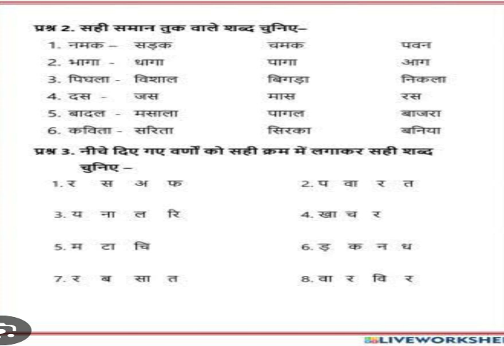

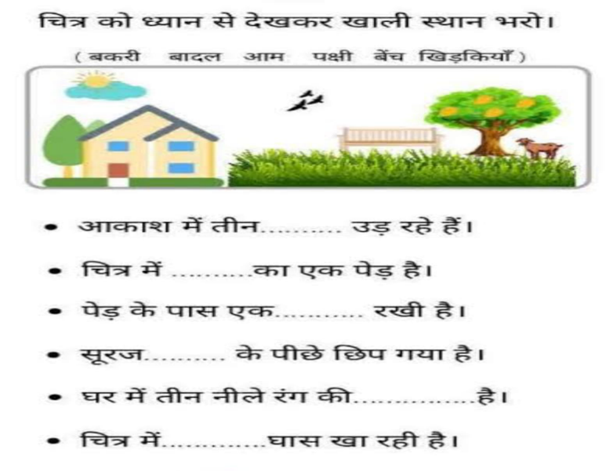

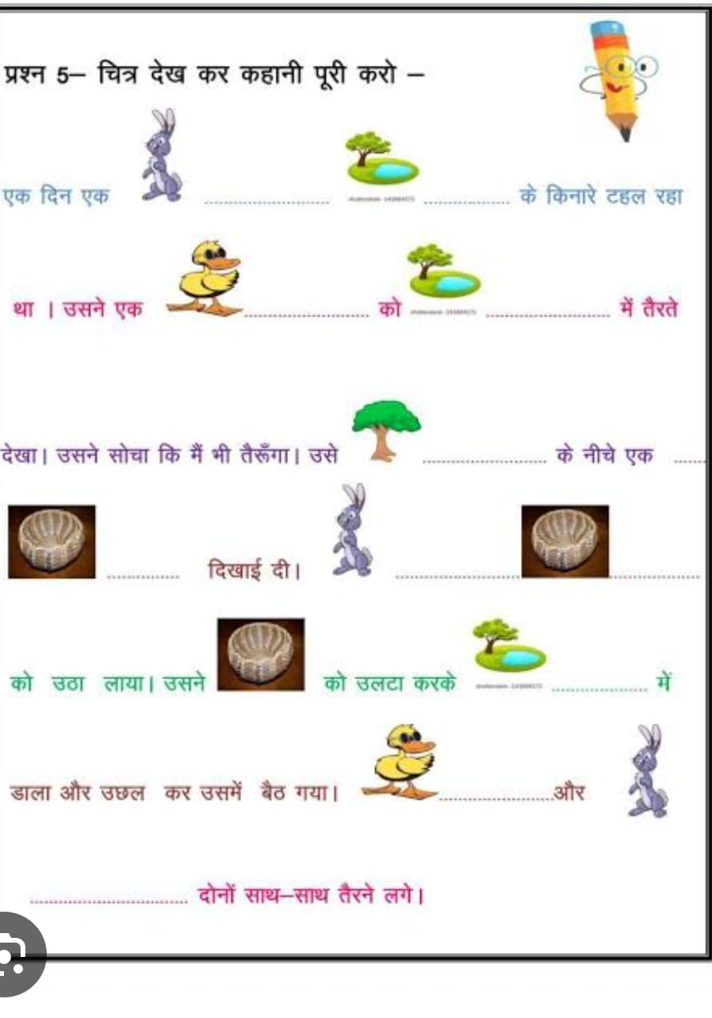

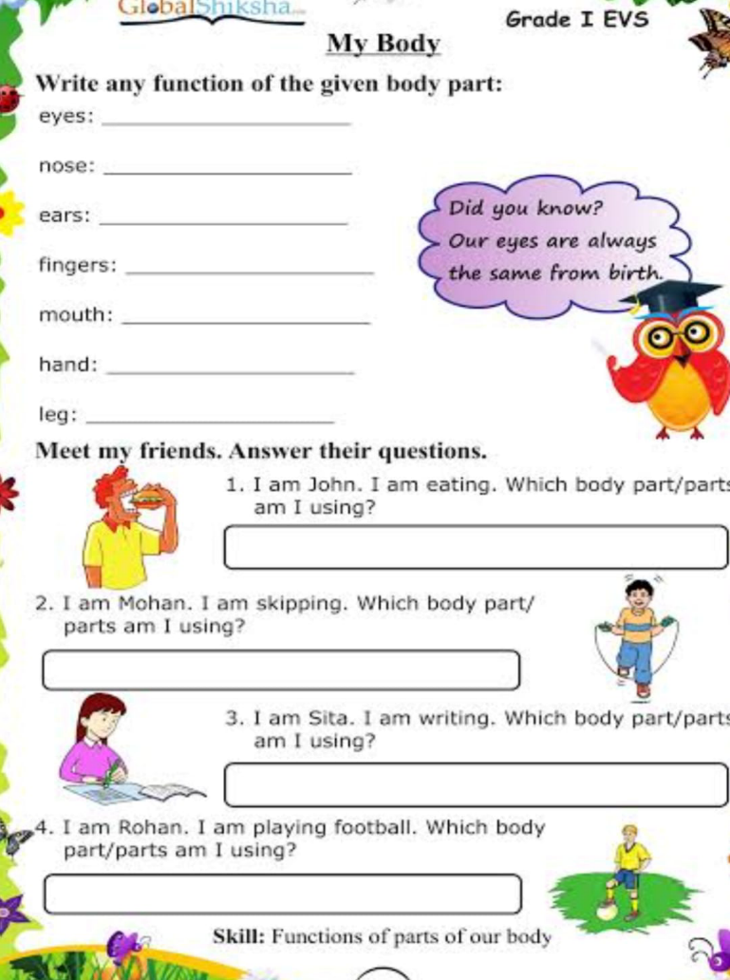

**Class-IInd**

**English**

**\*Write 5 pages of English writing.**

**\*Make a flower with the help of colour paper and write 'ar'sound words on it.**

**\*Write 20 noun  words in English notebook.**

**\*Learn all the work done in book and notebook.**

**Maths**

**\*Learn and write tables 2 to 9.**

**\*Complete page number 38,39,40,45  in maths  book.**

**\*Make an abacus for class practice.**

**\*Write number name from 101 to 150 in your maths notebook.**

**EVS**

**\*Make a chart of food which you get from plants and animals.**

**\*Make small envelopes with the different colour paper and put in different type of grains and  pulses and paste it  in your scrapbook.**

**\*Learn all the work done in book and notebook.**

**हिंदी**

**\*पाठ १ सीखो कविता याद करो!**

**\*5 पेज सुलेख लिखिए!**

**\* छोटे डिस्पोजल पेपर ग्लास की सहायता से कूड़ेदान बनाएं।**

**\*पाठ 3 के आधार पर पेड़ का का चित्र चार्ट पर बनाएं एवं उसके  के बारे में पांच वाक्य लिखिए!**

**\*हिंदी पुस्तक व पुस्तिका में कराया गया समस्त कार्य याद करें!**

**Computer**

**Drawing and coloring: Draw a computer, keyboard, mouse, and monitor, and label the parts.**

**Identifying parts: Name the parts of a computer (e.g., monitor, keyboard, mouse, printer).**

**Practical activity: Collect pictures of different types of computers (desktop, laptop, smartphone, tablet) and paste them on a sheet.**

**G.K**

**\* Make a small swing with the help of thread ,stick and cardboard.**

**Do this work in your GK notebook.**

**Name the following questions-**

**• Name the largest continent....................**

**• Name the smallest continent.....................**

**• Name the largest country.........................**

**• Name the highest mountain...................**

**• Name the largest ocean........................**

**• Name Largest desert.............................**

**• Name the longest river...........................**

**• Name any monument....................**

**• The planet which is home for all forms of life................**

**नैतिक शिक्षा**

**१. गायत्री मंत्र लिखे एवं याद करिए।**

**२. महर्षि दयानंद के बारे में पांच वाक्य  उत्तर पुस्तिका में लिखें।**

**३. दस  अच्छी आदतें नैतिक शिक्षा की उत्तर पुस्तिका में लिखें और याद करें।**

**Art**

**Step by step**

**Step Pruge 1 to 10**

**Birthday card, Tree with Buttefly.**

**Thumb impressions in bunch of balloons.**

**Make a National flag.**

**Draw the flowers and paste the pencil shreded.**

**( Class-3)**

**Instructions**

**• Present your holiday homework in an attractive manner with neat and clean handwriting.**

**विषय हिन्दी -**

**१) किसी भी मनपसंद जानवर का  मास्क बनाइए तथा स्कूल खुलने पर उससे संबंधित कहानी सुनाइए।**

**२) 5 जून (विश्व पर्यावरण दिवस) आप जहां कहीं भी हो वहां  वृक्षारोपण कीजिए।**

**३) वृक्ष विषय पर छोटी सी कविता लिखिए (आठ पंक्तियों में) तथा चित्र भी बनाइए।**

**४) प्रोजेक्ट कार्य: मेघालय का चित्र बनाकर या लगाकर (A4 साइज शीट) 8 नाम वाले शब्द लिखिए।**

**५) भारत देश हाथी और चिड़िया याद करिए एवं पांच पेज का सुलेख लिखिए।**

**SUBJECT: ENGLISH**

**Q1. Paste the picture of any two pet animals and two wild animals on A4 size sheet.**

**Q2. Write a paragraph on "My best friend " (five lines) Q3. Write answers of Q. B7 and B8 from "My English Reader"**

**Q4. Learn the poem "At the zoo".**

**Q5. Make a chart mentioning five naming words and five common words.**

**Q6. Complete the page number 71,72 and 73 of your practice book.**

**Q7. Learn all the work done in book and notebook.**

**MATHS**

**BRAIN TEASERS OF  UNIT -1 AND UNIT-2**

**Q-1 Write the expanded form:**

**5467 5 Thousands + 4 Hundreds + 6 Tens + 70nes**

**3040 Thousands + Hundreds + Tens + Ones**



**1568 Thousands + Hundreds + Tens + Ones**



**1832 Thousands + Hundreds + Tens + Ones**



**3546 Thousands + Hundreds + Tens + Ones**



**1080 Thousands + Hundreds + Tens + Ones**



**Q-2 Encircle the correct numeral:**

|  |  |  |  |
| --- | --- | --- | --- |
| **a) 6 Thousands + 4 Hundreds + 3 Ones —** | **6340** | **6403** | **6043** |
| **b) 9 Thousands + 5 Hundreds + 9Tens** | **9590** | **9905** | **9095** |
| **c) 3 Thousands + 8 Hundreds** | **3080** | **3800** | **3008** |
| **d) 4 Hundreds + 3 Ones —** | **403** | **430** | **4003** |
| **e) 5 Thousands + 6 Ones =** | **5060** | **5006** | **5600** |
| **f) 7 Thousands + 9 Ones —** | **7090** | **7009** | **7900** |

**Q1. Which place should we compare to determine the greater of the given numbers**

**243608 and 243698 ?  _________________________**

**a) Tens  b) hundreds c) thousands d) ones**

**Q2. The numeral for 6000 + 30 + 5 is  ______________**

**a) 6305  b) 6035  c) 635 d) 653**

**FILL IN THE BLANKS: (2X1=2)**

**Q3. The smallest 4-digit number is __________________**

**Q4.  The successor of 5139 is  ____________**

**Answer The Following: (2x1)**

**Q5.  Write the smallest 4-digit number using the digits 9 , 2 , 8 and 0 only once.**

**Q6. Write the number name of 4619.**

**Short Answer Type question – I ( 2 x 2 =4 )**

**Q7. Draw an abacus and show the place value of the underlined digit in 9 0 7 5.**

**Q8. Write the expanded form of 6734 in two ways.**

**Short Answer Type question – II ( 2 x 3 = 6 )**

**Q9.  Compare using > , <  , =**

**1389  ________ 1938       2020  ________  2002   999  ________  9099**

**Q10. a)Write the successor of the largest 3-digit number.**

**b)Write the predecessor of the smallest 4-digit number.**

**Long Answer Type question**

**VBQ**

**Q11. Trees play a very important role in our life. On the Vanmahotsav Day each  child of class II and III was asked to bring a sapling in a pot. Class II and III  brought 95 saplings and 150 saplings respectively.**

**a) Which class brought more sapling and how much ?**

**b) What values reflected by the students here ?**

**SCIENCE**

**1. List 10 items each that you will have in summers with sour, salty, bitter and sweet taste .**

**2. Draw a neat and labelled diagram of plant and mention the functions of each part of a plant.**

**4. Make a paper bag with old newspapers and decorate it.**

**5. Grow a plant sapling in a small pot. Water it daily and observe the changes taking place in it.**

**6. Revise ch. 1 "My Body" ch. 2 "Plants Around Us" which is done in the class.**

**7. Observe the weather daily and prepare a chart of the same using different little emoticons. You can make clouds for cloudy, smiling sun for sunny days, etc., and put them on the chart.**

**S. St**

**Q 1.Complete Q. No. 1,3,4 and 5 of page number 23 of SST Book.**

**Q2. Do Q. No. 5 and 6 of page number 32 of your book.**

**Q3.Draw any two food items you get from plants and animals on A4 size sheet.**

**Q4. Draw a family tree on cardboard (Height size= 10 inches).**

**Q 5.Learn all the work done in book and notebook.**

**Note:- Students are requested to do their holiday homework in a separate file.**

**COMPUTER**

**Project work: Make a model on any part of computer.**

**Writing assignments: Write about the uses of computers, or the importance of computers in daily life.a**

**Online safety: Learn about online safety tips and discuss them.**

**G. K**

**Complete all activities in a separate notebook.**

**Use pictures, drawings, or magazine cutouts where mentioned.**

**Write neatly and use color for headings**

**1. Know Your Country**

**Write 5 facts about India (capital, national symbols, famous monuments).**

**Paste or draw pictures of:**

**National Flag**

**National Animal**

**National Bird**

**.My Favourite**

**Draw and write about:**

**Your favorite fruit**

**Your favorite sport**

**Your favorite cartoon character**

**विषय : नैतिक शिक्षा**

**• . नैतिक कहानी पढ़ो और सीखो**

**कोई एक नैतिक कहानी पढ़िए (जैसे – "ईमानदार लकड़हारा", "सिंह और चूहा")।**

**अपनी कॉपी में लिखिए:**

**कहानी का नाम**

**कहानी से मिली सीख (moral)**

**कहानी से जुड़ी एक तस्वीर भी बनाएं।**

**प्रश्नोत्तर:**

**नीचे दिए गए प्रश्नों के उत्तर लिखें (3-4 पंक्तियों में):**

**हमें बड़ों का आदर क्यों करना चाहिए?**

**सच्चाई बोलने से हमें क्या लाभ होता है?**

**अगर कोई दोस्त गलती करे तो आप क्या करेंगे?**

**हम स्कूल और घर में अनुशासन कैसे बनाए रखें?**

**Art**

**Stap by step book**

**Page no.1to 10**

**Draw and colour**

**Birthday party articles**

**Thumb impressions in**

**Butterfly with flowers**

**Make a National flag with stick**

**Class -IV**

**A.  English:**

**1. Make a chart of pronouns under these headings:**

**• Subject Pronoun**

**•Possessive Pronoun**

**•Object Pronoun**

**2. Draw or paste pictures of people or animals.Write one sentence under each using a pronoun.**

**3. Write a paragraph on a true friend.**

**4. Which game do you like the most? Write 5 lines about your favourite player.**

**5. Learn all the work done in book and notebook.**

**Hindi:**

**१) गांधी जी के तीन बंदरों का चित्र बनाइए एवं उनसे मिली सीख लिखिए।**

**२) 1 से 20 तक हिंदी की गिनती लिखिए।**

**३) किसी प्रसिद्ध कहानी का सचित्र वर्णन कीजिए।**

**४) (A-4 साइज शीट) पर तीन मुहावरे लिखिए तथा उनके चित्र बनाइए।**

**५) पॉंच पेज का सुलेख लिखिए।**

**Social Studies :**

**1.My Family and Community**

**Make a family tree with photos or drawings of your family members.**

**Write 5 lines about the role of each family member at home**

**2.Collect pictures of community helpers (doctor, teacher, firefighter, etc.).**

**Make a collage and write 1-2 lines about how each helps us.**

**Science :**

**📌SUBJECT ENRICHMENT ACTIVITY**

**👉ACTIVITY NO 1**

**\*Open Your Mouth\***

**Collect the following data of your family members and summarize the information in scrap book**

**1 PICTURES**

**2 RELATION WITH STUDENT**

**3 NAME**

**4 AGE**

**5 NO. OF TEETH**

**6 TYPE OF TEETH**

**👉ACTIVITY 2**

**\*Beauty of Nature\***

**Collect the following original parts of plant and paste them in scrapbook**

**1) 4 Different types of leaves**

**2) 4 Different types of flowers**

**3) 2 types of roots**

**General knowledge (G.K):**

**Kid Wiz book**

**Page 1to10 learn all work**

**Make a chart showing Gadgets Around**

**Make a chart paste the pictures of freedom fighters**

**Write any ten current affairs important news.**

**Read news papers daily.**

**F नैतिकशिक्षा:**

**पाठ १, २का समस्त कार्य दोहराए।**

**डी. ए. वी. गान याद करिए और लिखिए।**

**स्वामी दयानंद जी पर पांच वाक्य लिखिए वह चित्र भी लगाए।**

**हवन कुंड का चित्र बनाकर तीन बार गायत्री मंत्र लिखिए।**

**यज्ञ  प्रार्थना याद करके लिखिए।**

**Computer:**

**Writing assignments: Write about the uses of computers, or the importance of computers in daily life.**

**Project work: Create a model of a computer using cardboard or other materials.**

**Online safety: Learn about online safety tips and discuss them.**

**Art:**

**Step by step**

**Page 1to10**

**Draw and colour-**

**Poster on garden scene, I love my country**

**leaf impressions painting,thumb impressions painting, Air blowing painting**

**Make a Wall hanging use the waste materials**

**MATHS**

1. **BRAIN TEASER OF UNIT -1 AND UNIT-2**
2. **WORKSHEETS**

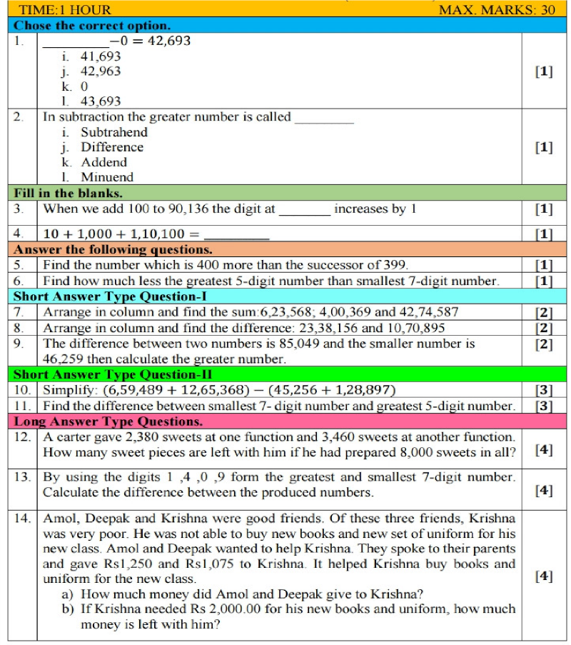

**Unit – 1    Numbers up to 9,99 ,999 Worksheet for Minimum Learning for Topic- CH.-1**

**Q1)What number does the bead show on the abacus?**

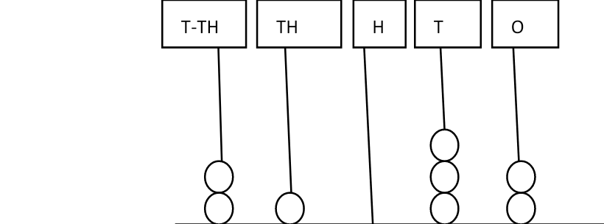

**Q2 Represent the number35820 on the abacus.**

**Q3. Write the number names for the following.**

**39,005  _________________________________________________________________________________8,06,897 _______________________________________________________________________________ Q4. Write the numerals :**

**Six lakhs_Forty Seven thousand two _______________________**

**Q5. Write down the period and place of the underlined digit in each numeral.**

|  |  |  |
| --- | --- | --- |
| **Numeral** | **Period** | **Place** |
| **56, 753** | **__________________________** | **_______________________** |
| **2, 47, 765** | **_________________________** | **__________________________** |

**Q6. Tick the correct option:**

1. **The smallest four digit number is (1,111,     1000,         1056)**
2. **The numeral in which the place value of 6 is 60,000. (3,56,002        2,60,789         4,77,600)**

**Q7. Fill in the blanks.**

1. **The numeral just before 10, 009 is _____________________________. b The greatest 5 digit numeral is __________________________.**

**Q8 Write the number 1,25,764 in expanded form in any two ways.**

**Q9. Write the standard numerals**

1. **60,000 +  5,000 +  300 +   20  +5 = _____________________________**

**4,00,000 + 20.000 +  5,000 + 700 + 30 +8 _______________________**

**Q10. Compare ( Put<,>or =) a  2,560                    ___   Two thousand eight**

1. **57,002  _____  Six lakh**

**Q11. Rewrite the following numerals in ascending order.**

**35,890;       46, 678;     10,456;     24,678**

**Q12 Rewrite the following numerals in descending order.**

**5, 67, 008 ; 4, 45,789 ; 9, 34,564 ;  3,54,321**

**Q13. Encircle the smallest numeral from each set of numerals.**

**11, 004 ; 3,009 ;  34,009 ; 1, 004**

**Q14 Encircle the greatest numeral from each set of numeral.**

**2,00,897 ; 40, 987 ; 45,879 ; 5,98,768**

**Q15. Write down the place value of the underlined digit.**

**4 5, 6 7 8 ____________________ 5, 7 8, 908 ___________________________**

**Q16. Form the greatest and smallest five digit number using each one of these digits only once.**

**Greatest number ______________________________**

**3        5        0**

**Smallest number _______________________________**

**7         9**

**Q17. Compare the place value of the underlined digits in the numeral  54  0  4  3**

**Q18. Which numeral has less digits----Smallest 4 digit number   or     greatest 5 digit numeral.**

**Q19.  Write down the numeral which is one less than the greatest 4 digit numeral.  ______________________ Q20. Mention the places in Thousands and Lakhs period.**

**Class 5th**

**विषय: हिंदी**

**१)पुस्तक समीक्षा: किसी भी पुस्तक की कहानी को पढ़कर उनमें से किसी एक मनपसंद कहानी की समीक्षा(A4 साइज शीट) कीजिए। कहानी का नाम, लेखक/ लेखिका का नाम, पात्रों के नाम, कहानी से मिलने वाली शिक्षा या सीख, कहानी में अच्छी लगने वाली कोई दो बातें लिखिए तथा कहानी से संबंधित चित्र लगाइए /बनाइए।**

**२)प्रोजेक्ट कार्य: अपने दादा-दादी या नाना नानी में से किसी एक व्यक्ति का साक्षात्कार लेकर उसे संवाद रूप में (A4 साइज शीट पर) प्रस्तुत करें तथा उनका चित्र भी लगाइए।**

**३)A-4 सीट पर हिंदी की चार कहावतें लिखिए तथा उनका अर्थ भी लिखिए। जैसे :घर का भेदी लंका ढाए ।**

**४)स्वतंत्रता सेनानियों की सूची बनाइए A-4 सीट पर।**

**५)समस्त हिंदी में कराया गया कार्य याद करें।**

**Sanskrit**

**1-मम परिचय**

**2- 5 पशुओं के, 5 फलों के , 5 सब्जियों के चित्र चिपका कर उनके नाम संस्कृत में लिखने हैं।**

**3- संख्या 1 से 10 तक संस्कृत में ( पृष्ठ संख्या -64 )**

**4- अपने प्रिय पशु ,पक्षी, फूल,फल, सब्जी का चित्र बना कर उनके रंग भरने हैं।**

**(कक्षा में करवाया गया समस्त कार्य याद करना है।)**

**नैतिक शिक्षा:**

**१)एक चार्ट पेपर पर गायत्री मंत्र लिखिए। हिंदी की कैलीग्राफी लेख में तथा ओम का चित्र बनाइए।**

**२) एक ड्राइंग शीट पर आर्य समाज के पांच नियम लिखिए।**

**S.ST**

**1- Draw & colour flag of  India 's neighbourhood countries &paste  them in  your  S.st note book.**

**2 - Draw & colour  two means of  communication &Transportation  in your s.st note book.**

**3 - On a political map of India Mark, Labal &Colour  the  following  :**

**(a) State where  Surajkund**

**is located.**

**(b) A state which  receives**

**the  highest  rainfall.**

**(c)A state which is known as**

**' Gods own country.**

**(d) A state where garden city**

**of India is located.**

**(e) State which witnessed floods at Kedarnath pilgrimage in 2013.**

**Science**

**Topics Covered:**

**My Body**

**Forests**

**Plants**

**1.*Project Work (Choose One)\***

**\*A. Poster – “Save Forests”\***

**Make a colorful poster showing the importance of forests and how we can save them.**

**Add slogans like “Forests are Life” or “Save Trees, Save Earth”.**

**\*B. Leaf Collection Album –* Plants Around Me**

**Collect 5 different leaves from plants near your home.**

**Paste them in a notebook or scrapbook.**

**Write the name of the plant, where you found it, and one use (if known).**

**\*2. Fun Activities\***

**\*A. “My Body” Observation\***

**Count how many times you blink in 1 minute.**

**☆Find your pulse by placing fingers on your wrist. Count how many beats you feel in 1 minute.**

**Record and write your results.**

**\*B. Seed Germination at Home\***

**☆Soak a few moong or rajma beans overnight.**

**☆Place them on wet cotton and observe them daily.**

**☆Paste pictures or draw what happens in 5 days**

**\*Instructions* :**

**Complete the work neatly in a scrapbook or folder.**

**You can decorate your work with drawings, stickers, or pictures.**

**Art'**

**Step by step**

**Page 1to10**

**Draw and colour--**

**Poster on Safety on the road, Picnic scene**

**Make paper flowers with flower vase**

**COMPUTER:- Project work: Build a computer model, or create a presentation on a computer topic.**

**Written assignments: Write about the different types of computer software, or the importance of the internet.**

**Research: Research and write about a specific computer-related topic.**

**G.K-**

**Page no. 26 to 35**

**20 Current affairs**

**1. Read what some children have to say about their school life(page no 2). Write a paragraph what you like or dislike about your school life.**

**2. Write down the things you have to do as the monitor of the class.(5 sentences)**

**3. Practice book page no 118-128**

**4. Make a chart of countable and uncountable nouns. Draw or paste pictures of them, and write their names.**

**5. Learn all the work done in book and notebook.**